Six-point calibration method of VNA-O-Mizer by Daniel Marks KW4TI

The raw data output of the VNA is captured using the IMACQ command. The IMACQ command has three parameters:

IMACQ <# frequencies> <start frequency> <end frequency>

which captures the raw data for <# frequencies> from <start frequency> to <end frequency>. The result is in the following format, which is the raw data captured using quadrature demodulated samples:

<frequency>,<port 1 in-phase reference>,<port 1 quadrature reference>, <port 1 in-phase voltage>,<port 1 quadrature voltage current>, <port 2 in-phase current>,<port 2 quadrature current>

The number of averages which influences the dynamic range is set by

AVERAGES <# averages> <timeout in ms>

where the default number of averages is 64 for a 40 to 45 dB dynamic range, which increases to about 50 to 55 dB for 1000 averages which slows down the acquisition.

The calibration method is as follows. Three complex numbers are formed from this data:

It is assumed that the actual voltage and currents at port 1 are the linear combinations of and :

We can form the estimated impedance at the port by dividing these:

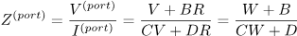

with 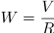

If we place three impedances , , and on the port and measure the corresponding reference and voltages , , and port voltages , , . From these , , and are computed. Then B, C, and D can be solved for:

If we simplify this so that for an open circuit and are measured, for a short circuit and are measured, and for a termination of and are measured, from which , , and . Then B, C, and D can be solved for:

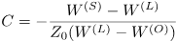

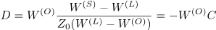

When you actually measure an impedance at channel 1, you will measure a complex-valued reference sample and port voltage sample These are divided to form . The actual impedance is then calibrated from the following bilinear transformation

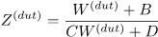

where B, C, D, are the three complex-valued calibration parameters for port 1. These parameters are captured for each frequency.

For port two calibration, first the isolation between port 1 and port 2 is found. The raw complex-valued current at port 2 is . The isolation is measured at port 2 during the port 1 load-circuit measurement step when the termination is on port 1:

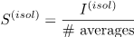

The total amount of signal leaking from port 1 to 2 scales with the number of averages, so the calibration is stored normalized by the number of averages.

To calibrate the impedance and gain at port 2, port 1 is connected to port 2. The raw current is sampled at port 2 . At the same time, the samples of reference and port voltage are measured at port 1. Then the following two parameters are calculated for port 2:

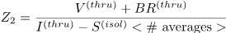

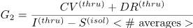

To calculate the complex-valued , use

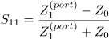

from which SWR, dB, and degrees may be determined.

To calculate

To calculate the thru impedance in series impedance mode

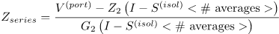

and the thru impedance in shunt mode

